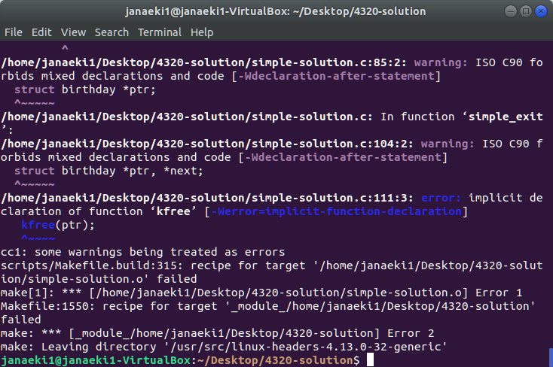

First, I made sure to have the “simple-solultion.c” source file and makefile in a separate directory. Then, I used the code in the makefile to attempt to compile the “simple-solultion.c” file and create a kernel module. However, I could not get the file to compile to create the module. I received error messages for “kfree” and “kmalloc” (not shown in screenshot).